Kwangmin Kim

CST-221

05/26/2019

John Jupan

System and tool

In a computer, there are various features to operate a system. One would be window OS. I think window OS is an application layer which is a part of OSI model. It has its own firewalls, HTTP, and booting system. Also, power cable and all the lines are very basic but really important in computer operating system. For network layer, there is WIFI as known as wireless network. To have a wifi, there must be a LAN cable and a router to change data from LAN to wireless network. Lastly, all the applications in my computer help to operate computer system faster and easier.

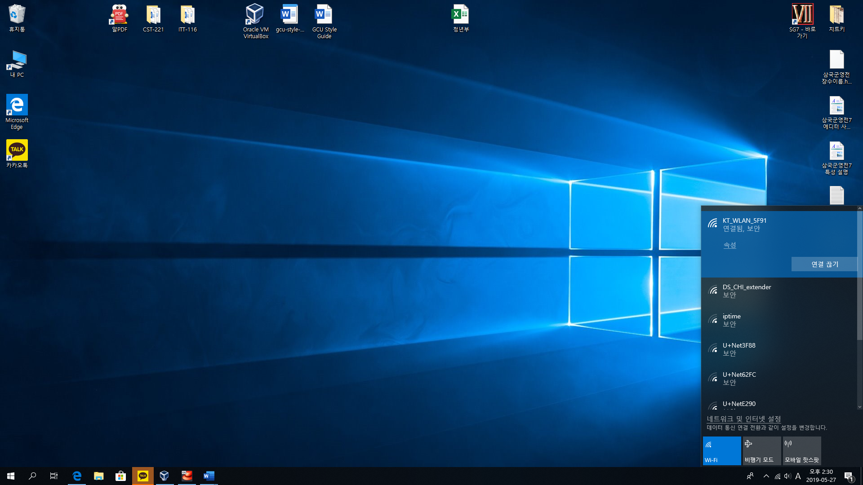wifi connection

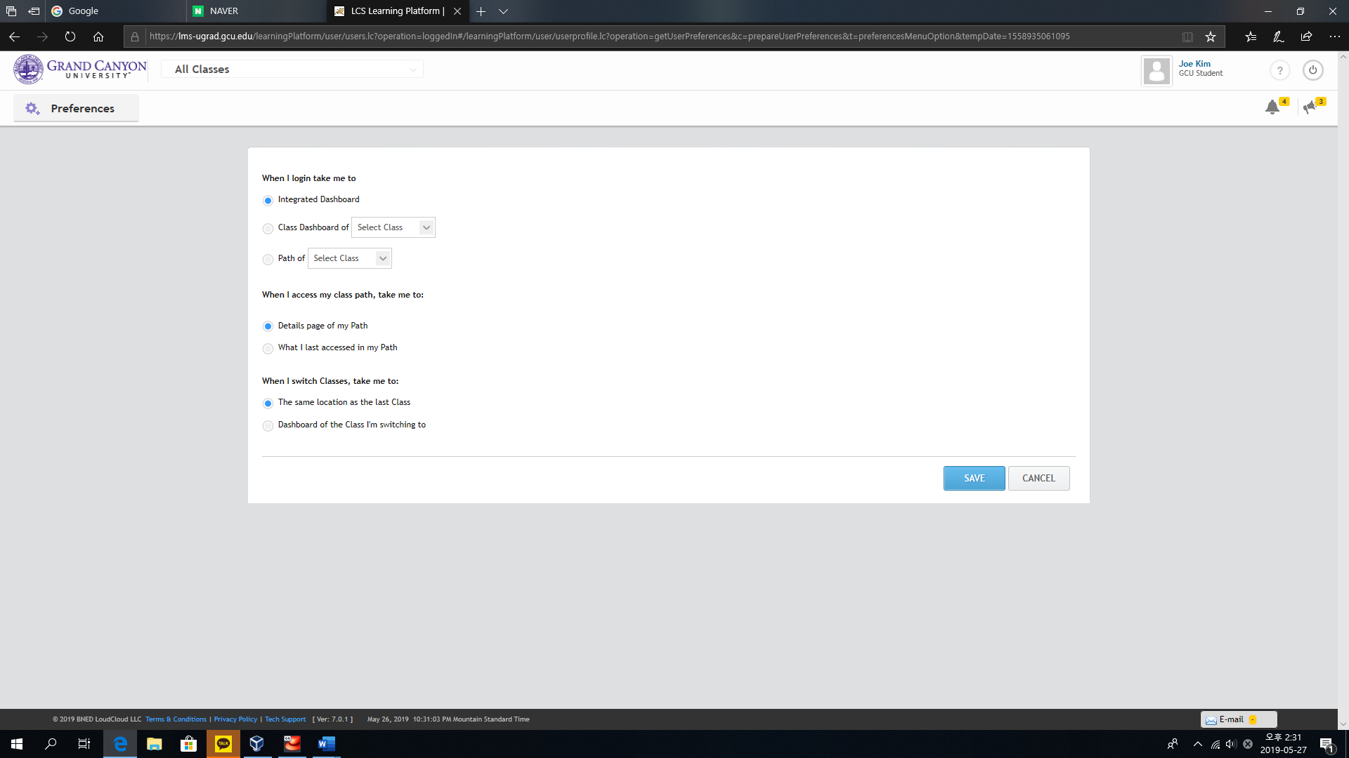 HTTP server

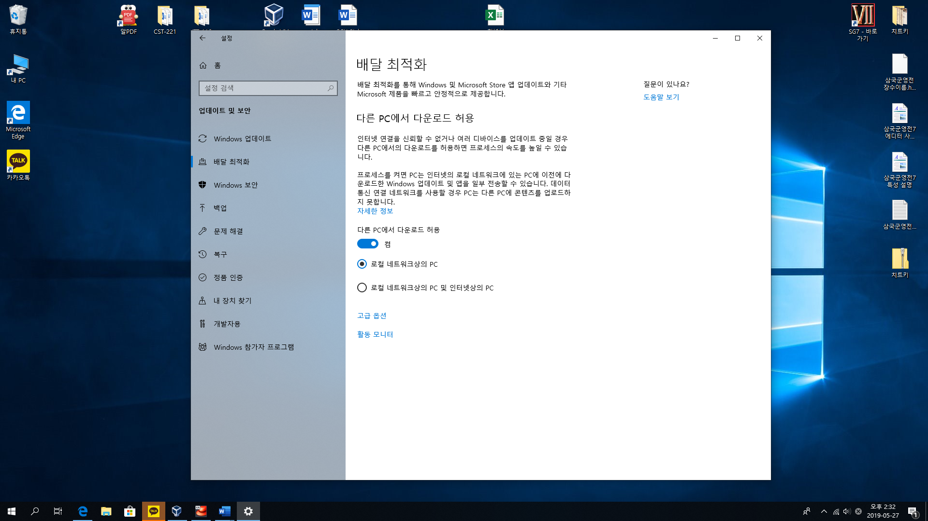 application that helps operating system

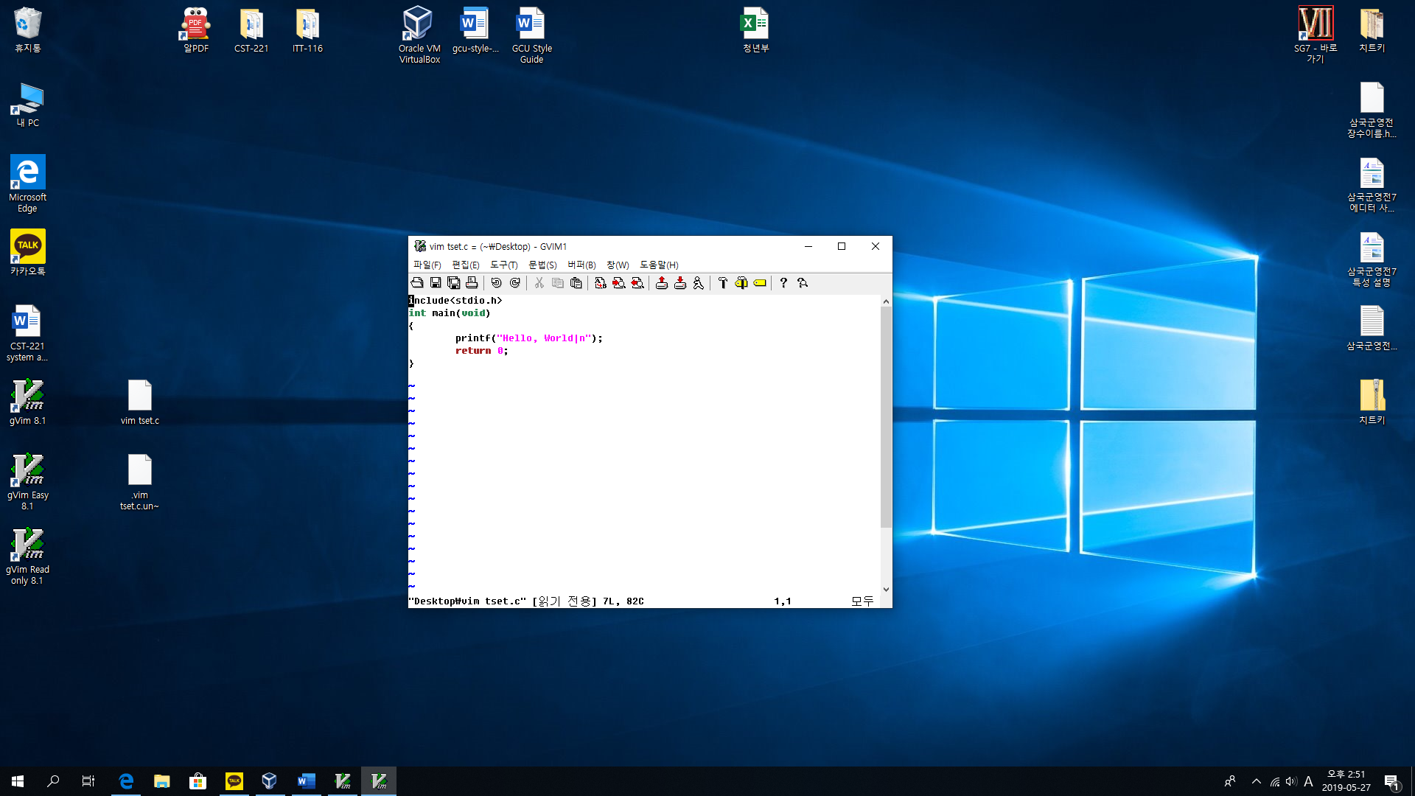

Github address:

<https://github.com/km0312/CST-221.git>